

SUPPLIER PAYMENT W/O INVOICE

EPTISA SERVICIOS DE INGENIERÍA S.L
PMO

Tipo de manual / manual type: Quick Guide

 |  | Version: 1.0
Author | Sergio Fernández | 2024-06-24
Review | Sergio Fernández / Tom Ye | 2024-06-24
Approval | Tom Ye | 2024-06-24

Index
1. INTRODUCTION 3
2. LOGIN 4
3. SUPPLIER PAYMENT W/O INVOICE 6
3.1. Supplier Payment Menu 6
3.2. Supplier Paymen Creation 7
3.2.1. Form Payment Information 7
3.2.2. Form Project Information 8
3.2.3. Form Invoice Information (Pro-forma ONLY) 8
3.2.4. Approval WorkFlow 9
3.3. Frequency Questions & Answers 9
3.3.1. Who has access? 9
3.3.2. How could I follow my Supplier Payment? 10
4. Check Pending tasks 11
5. CONTACT MiTools Team 12

INTRODUCTION

This manual describes the procedure for registering SUPPLIER PAYMENT W/O INVOICES.

New Supplier Payment w/o Invoices will be registered using only Mitools.

LOGIN
Access to the new platform typing the address MITOOLS.EPTISA.COM in the browser:
(It is advisable to use the Microsoft EDGE browser because Chrome causes access problems).

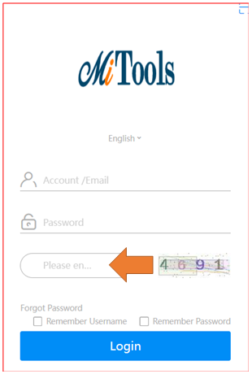

On the login screen, use the same username and password that you use on the eptisa intranet.
Additionally you have to enter the numerical code.

Once connected to the Mitools platform, the homepage is displayed.
A pending task warning symbol will appear on this screen.

You can also access the tasks by selecting PROCESSES from the menu.

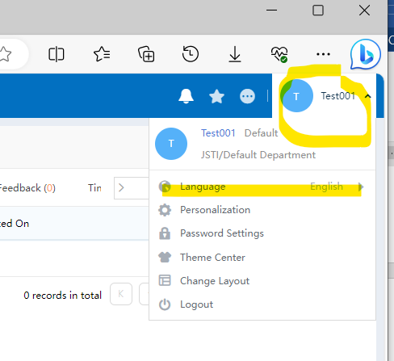

To change the language, select the drop-down menu that appears next to your name.

SUPPLIER PAYMENT W/O INVOICE

Supplier Payment Menu
This are the way for SUPPLIER PAYMENT and the functions we have to work with:

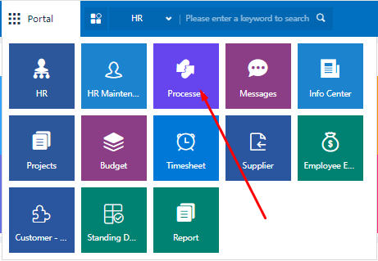

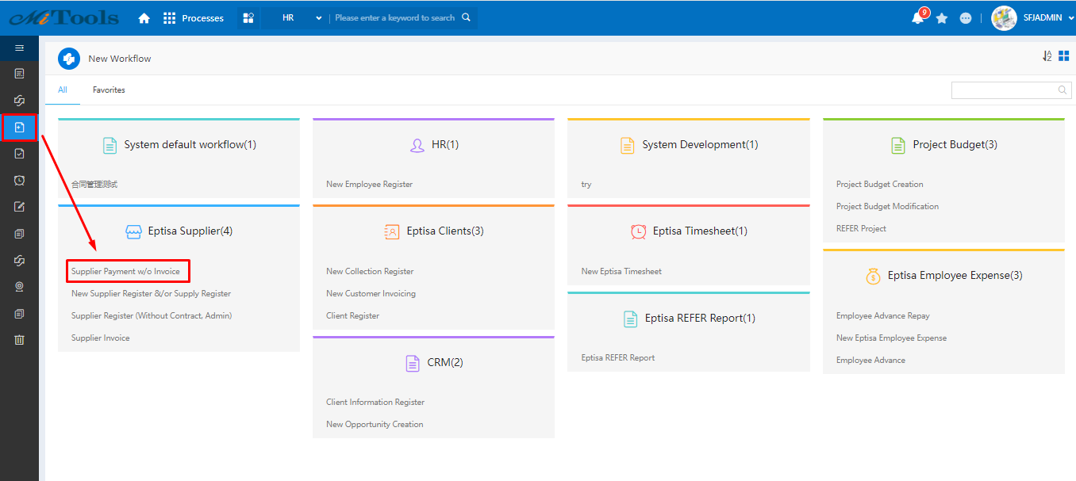

Supplier Payment Creation
This is a workflow which follow similar functionalities than other.
User just need to fill the form and push SAVE or SUBMIT button depending on the case.

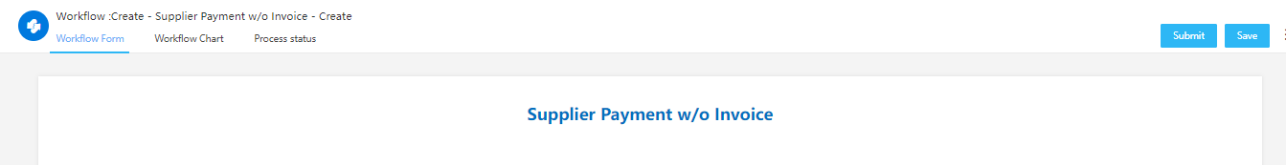

Form Payment Information
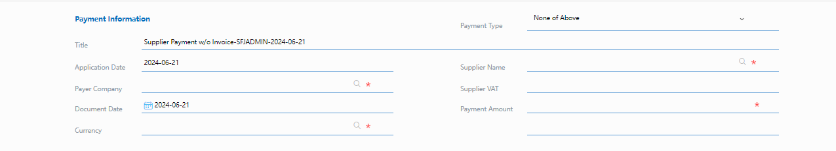

In this initial part, we need to decide which payment type select for our Supplier Payment.
This form has 3 Payment Types:

- Pro-forma
- Government Charges
- None of Above.

Depends which select the workflow take one-way or other way. These paths are explained in the Approval Workflow section.

For what data you need to provide, only need to provide:

- Supplier Name
- Payer Company
- Document Date
- Currency
- Payment Amount

The number of SUPPLIER VAT is an automatic field when you write a Supplier Name.
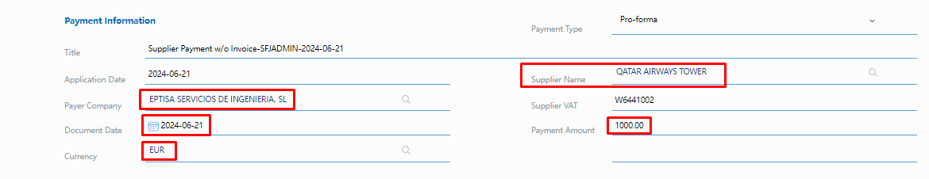

Form Project Information
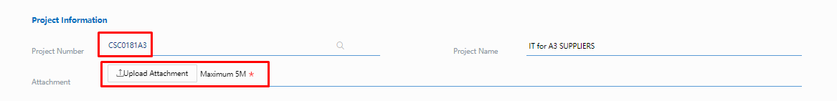

For project information only need to provide the Project Number, Project name is an automatic field when you provide a Project Number and is necesary to upload attachement.

Form Invoice Information (Pro-forma ONLY)
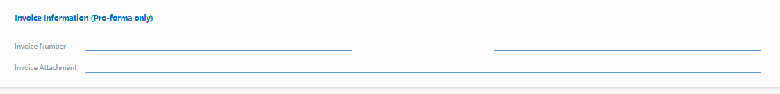

For this form part, you only need to leave empty. This part will provide the information by AP Accountants

Approval WorkFlow
This is the approval workflow.

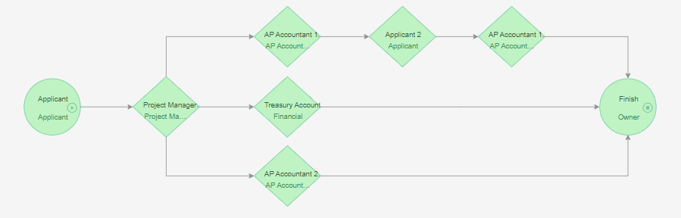

If you select Government Charges or None of Above in payment type, the approval workflow is normal like other modules. However, if you select Pro-forma, the workflow follow a different way and when pass the AP Accountant 1 node, come back to the applicant for provide more data about the invoice. When the applicant provide this information, come back again to AP Accountant to workflow approve.

This is a workflow, which follow similar functionalities than other.
User just need to fill the form and push SAVE or SUBMIT button depending on the case.

Frequency Questions & Answers

Who has access?
For this workflow can access all employees for make his Supplier Payment w/o Invoices

How could I follow my Supplier Payment?
To follow your payment, you can go to the Payment without Invoice List.

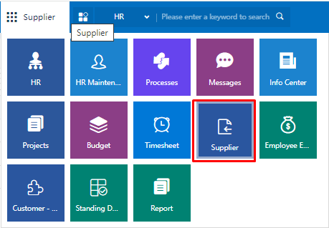

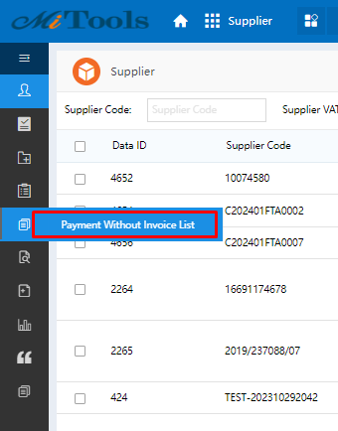

Check Pending tasks
A pending task warning symbol will appear on the homepage

Or you can select PROCESESS to check all tasks.

- To Do List : my pending tasks
- Handled : my tasks completed
- My Request : My requested tasks to others

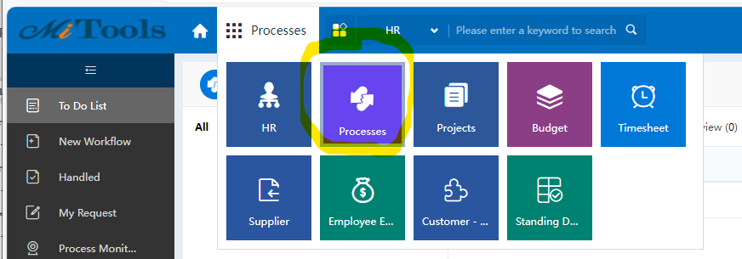

CONTACT MiTools Team

Please send any questions, issues, or information to email:

mitools.support@eptisa.com

